 | MINISTRY OF EDUCATION AND TRAINING

FPT UNIVERSITY

CAPSTONE PROJECT DOCUMENT
Bookstore Management System
Report #3 – Software Requirement Specification
Group Member | SE03975 - Olasehinde Ezekiel Olaoluwa
Group Member | SE03444 - Kanda Joshua David
Group Member | SE03520 - Shunom Peter Bala
Supervisor | Bui Đinh Chien
Ext. Supervisor
Project Code | BSMS

- Hanoi, 05/2017 -
Table of Contents
USER REQUIREMENTS SPECIFICATION 4
1.1 Introduction 4
1.1.1 Purposes 4
1.1.2 Definition and Acronyms 4
1.1.3 Scope 4
1.2 Overall Description 5
1.2.1 Product Features 6
2 SOFTWARE REQUIREMENTS SPECIFICATION 9
2.1 System Purpose 9
2.1.1 User Characteristics 9
2.1.2 User Documentation 9
2.1.3 Assumption 9
2.2 Entity Relation Model 10
2.2.1 Entity-Relationship Diagram 10
2.3 Functional Specification 11
2.3.1 Authentication Management 11
2.3.2 Category Management 18
2.3.3 Genre Management 24
2.3.4 Staff Management 30
2.3.5 Book Management 34
2.3.6 Watch List Management 42
2.3.7 Author Management 45
2.3.8 Profile Management 50
2.3.9 System Search 53
2.3.10 Producer Management 56
2.4 Non-functional Specification 61
2.4.1 Reliability 61
2.4.2 Performance Requirements 61
2.4.3 User Interface 62
2.4.4 Usability 62
2.4.5 Security Requirements 62
2.4.6 Hardware/Software Requirements 62

USER REQUIREMENTS SPECIFICATION

Introduction

Purposes
The main aim of writing this requirement document is to provide reviewer with adequate information with regards to BSMS. Reviewers will get insight of the overall system and detailed information about our system.
This document includes full description of the product such as the Stack holders, functional requirement, non-functional requirement, UI design and some other system descriptor.
This record is the product prerequisite determination (SRS) of our BSMS system, which comprise of two main sections: The User Requirement and The System Requirement Specification.

Definition and Acronyms
Term | Description
UI | User Interface
GUI | Graphical UI
BSMS | Bookstore Management System
SRS | Software Requirement Specification
UC | Use-Case
N/A | Not Available
DB | Database
CRUD | Create, Read, Update and Delete
Admin | Administrator
E-U | End-Users
Table 3-1: Definition and Acronyms

Scope

This document explains all in detail the overall requirement of BSMS, how you interact with the system and how the system respond to it.
The document applies to many stages of developing the system:
- One, the product supervisor need to use this document to evaluate the End-Product.
- It is as well very important for the developers, testers, UI designer and E-U
- Developers need to understand user requirement and the requirement specification in order to build the application correctly.

- Testers as well need to understand the functionalities of the system in-order to be able to know which part of the system is not working correctly.

- Since UI designers need create a user interface for the system, and one of the utter-most things to consider when doing this is to understand the different type of users in the system thus they will be able to create interactive UI for each set of users.

Overall Description
Figure 1.21 show overall use case diagram of BSMS, our system provide full information management feature including Add Books, Users Account, etc. as shown in the figure below each stake holders of the system and level of access (who can do what, what can a particular user type do?).

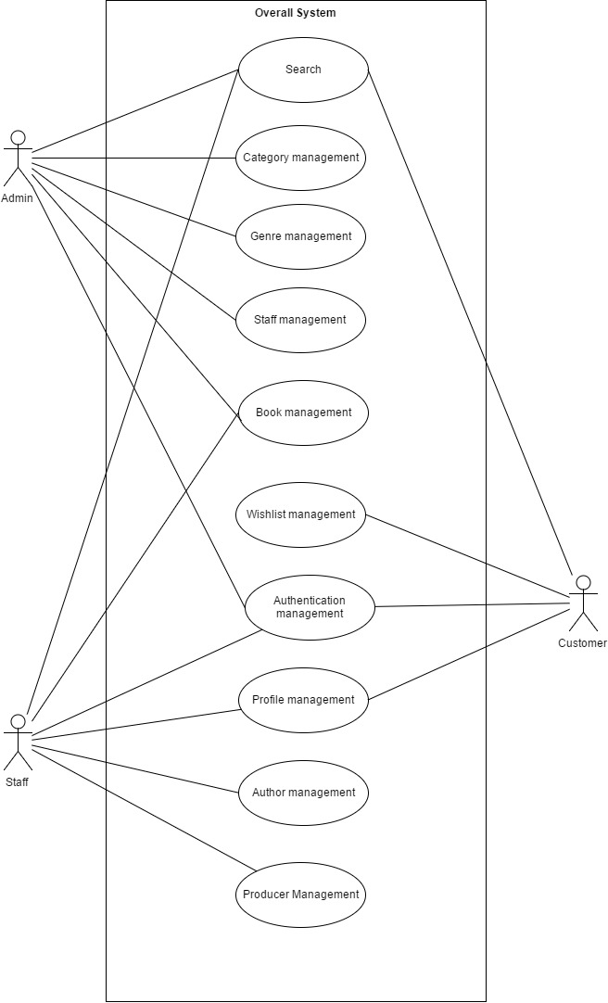

Figure 1.21

Product Features
The list below offers a brief outline of our system features and functionalities. The list is comprised of two major sections, the System Core features and Additional feature of the system. The core feature are those part of our system that are required for it work correctly, while the additional feature of the system are for feature purposes and they will be implement over time.
Core Features
Feature | Description
Authentication | Our system authentication features include the Login, Register, Logout, Forget Password and Change Password section.  This allows Users to gain full access to the system.
Category and Genre Management | Category and Genre is one of the most important part our system, as it allows user to be able group books into difference preferences. Administrator Access of this Feature includes the Create, Update, Delete and Read (CRUD)
Staff Management | Staff management of BSMS is a level of access allow by the Admin alone, actions like Create, Update, Delete, View Profile.  Stakeholders like staff can also update their own profile and view their profile.
Book Management | One of the core feature of the system is the book management as the name implies, Staff is allowed to add books, delete books and update book information, including price of book, and softcopy of the book, while the Admin of system is require to validate all those information, then approve or reject the book.  Approved books can seen in search while rejected once remains hidden in the system, with only admin and staff being able to access them. Customer features include the search, read online or download feature if book is free, if not then the system will only provide information.
Management | The Staff is allowed to make use of this functionality. Which include creation of example (The Hobbit, Lord of the Ring), after creation he/she can then add book under this series either existing books or new once
Watch List Management | This is the core functionally of the Customer, in which only the customer is allow to use this feature. With ability to keep track of read list, including Delete and Add Watch list
Profile Management | This feature is available to all stockholders apart from the guest; they can edit their profile information.
Author Management | Before books are being create, author of such books are required to have exist in the system thus the Staff is required to Add books authors into the system, including their background, Update and delete should also be available for staffs
Email Notification | Email Notification should be provide, as users can choose to receive update on subscription, lovers of books to receive update new book arrivals.
Producer Management | Producers in our system stands as those who produced a particular book, action like create, update edit and delete is totally allow on this functionality, and only the staff of our system is allow to access this functionally.
Search Functionality | This serves as the biggest part of BSMS as both all user types are allowed to access this. Users can search product name, search anything relating to book, producer, ISBN, Synopsis and many others.

SOFTWARE REQUIREMENTS SPECIFICATION

System Purpose

User Characteristics
There are specifically 4 type of user that interact with system, looking at the system from inner approach there are mainly 3 type of users which is the Admin, The Staff and Customers, an additional one will be the guest. Each and every one of these users has their own different level of access and they all have their own different requirements.
User | Characteristics
Admin | This user overseas the overall system, he’s main functionality is to approve new books and create new Staff. This is the most important part of BSMS, Category, Genre are all pushed by the admin.
Staff | Preceded by the Admin, staffs also have high level of access in the system as they are required perform CRUD functions on Books,
Customer | The customer in our system is only given limited access as they can either read books online or add book to their watch list.
Guest | The Guest has the lowest level of access as they can only view books.

User Documentation
Our target audiences in this case are bookstores and lovers of books who will like to keep track of new book in a particular bookstore and also it can serve as information management system to bookstores. For full user documentation on accessibility, kindly consult User's Manual Documents.

Assumption
It is assumed that the system will work as planed on both mobile devices and pc’s as we will be using the mobile first approach in design using the bootstrap UI designer and Viewport.

Entity-Relationship Diagram
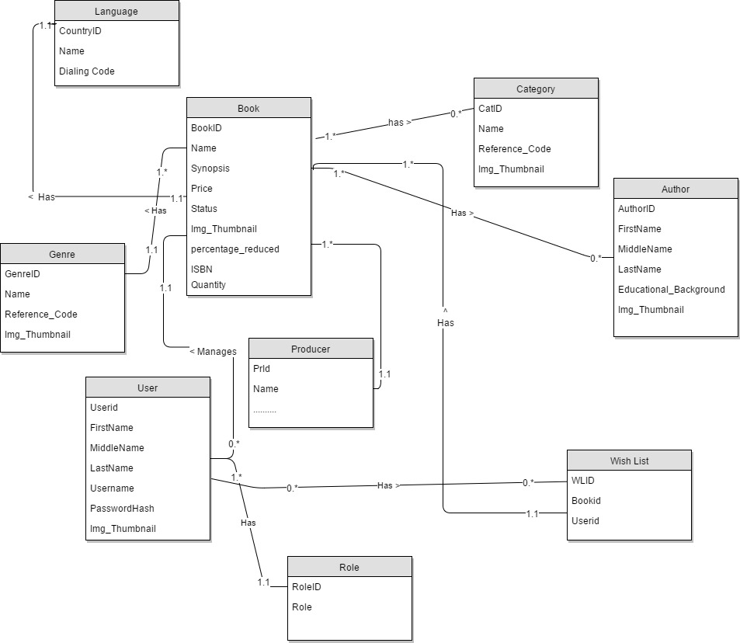

Functional Specification

Authentication Management
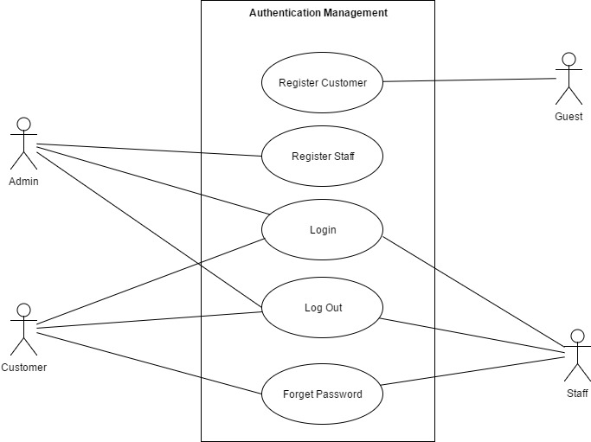

Login
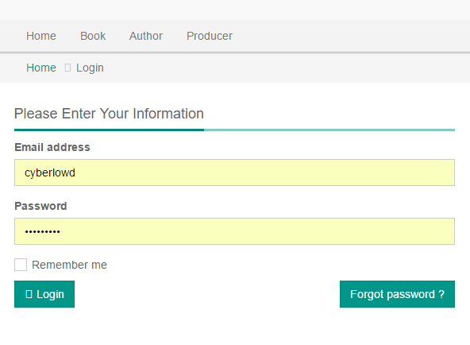

Use Case ID |  |  | AM01 |  | Version | 1.0
Use Name |  |  | Login
Actor |  |  | Customer, Staff, Admin
Description |  |  | This functionality specifically allows end-user to connect to the system, providing access to the overall in-built features. Users need to login to access their individual given level of access.  Login is the process by which an individual gains access to a computer system by identifying and authenticating themselves.
Precondition |  |  | - End user must own a computer of any type and also E-U must have internet connection  - E-U must access our website home page and then click on the login icon/button/link to navigate to the login page.  - E-U must own a valid login detail
Trigger |  |  | Login Button clicked
Post-Condition |  |  | Homepage
Main flows
Step | Actor |  | Action
1 | Customer  Admin  Staff |  | Type URL into location field of internet browser and then press enter
2 | BSMS |  | Display Login screen with the following fields:  - User Name  - Password  - Login button
3 | Customer  Admin  Staff |  | Enter user name & password into User Name & Password fields on the Login screen, and then click on the Login button.
4 | BSMS |  | Validate the entered user name & password and then display Home screen
Alternative flows
AT1 |  | Alternative flow, should incase an error occur in the program, either username or password is incorrect.
Step |  | Actor |  | Action
4 |  | BSMS |  | Display Login page with message "Your user name or password is incorrect."
AT2 |  | Username or Password field are is empty
Step |  | Actor |  | Action
4.1 |  | BSMS |  | Display login page with error message “Username and Password fields are required”

Business Rules
# | Rule Description
LGBR01 | Length of username must be greater than 4
LGBR02 | Password must contain at-least a number
LGBR03 | Password length must be greater than 5
LGBR04 | Username or Password cannot be empty

Register Customer

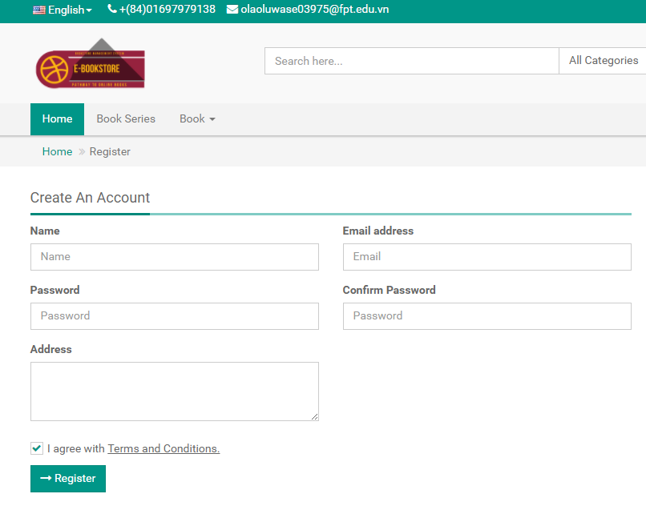
Use Case ID |  |  | AM02 |  | Version | 1.0
Use Name |  |  | Register Customer
Actor |  |  | Guest
Description |  |  | This functionality allow guest of BSMS to become a customer, thus they will be allow to the login functionalities BSMS, an also giving access to use all the functionalies of the system that match there prospective role
Precondition |  |  | - End user must own a computer of any type and also E-U must have internet connection  - E-U must access our website home page and then click on the login icon/button/link and then click on the Register to navigate to the Registration page.
Trigger |  |  | Register button clicked
Post-Condition |  |  | Registration Confirmation Page
Main flows
Step | Actor |  | Action
1 | Guest |  | Type URL into location field of internet browser and then press enter and navigate to the Register Page from the home page
2 | BSMS |  | Display Registration screen with the following fields:  - User Name  - Password  - Email  - ……..  - …….  - radio-button EULA term  - Register button
3 | Guest |  | - Fills in correct registration data in the (*) fields  - Check the Agree with Term of Service.  - Click the Register button
4 | BSMS |  | Validate registration information, if correct is correct entered in a normal case. Registration successful Information message is shown to Guest-User.
Alternative flows
AT1 |  | Alternative flow, should incase any internal error occur, ‘can’t connect to database’ or web service request failed
Step |  | Actor |  | Action
2.1 |  | BSMS |  | Display Error page with message "Internal System Error, please contact with administrator"
AT2 |  | Alternative flow, should incase an error occur in the program, if any of the (*) fields is empty or contains incorrect input.
Step |  | Actor |  | Action
4.1 |  | BSMS |  | Display Registration page with message “(*) fields are required and must contain valid values”

Business Rules
# | Rule Description
RGBR01 | Length of username must be greater than 4
RGBR02 | Password must contain at-least a number
RGBR03 | Password length must be greater than 5
RGBR04 | Username or Password cannot be empty
RGBR05 | Email Field must be valid
RGBR06 | Email cannot be reused, “Email Already in use”

Register Staff
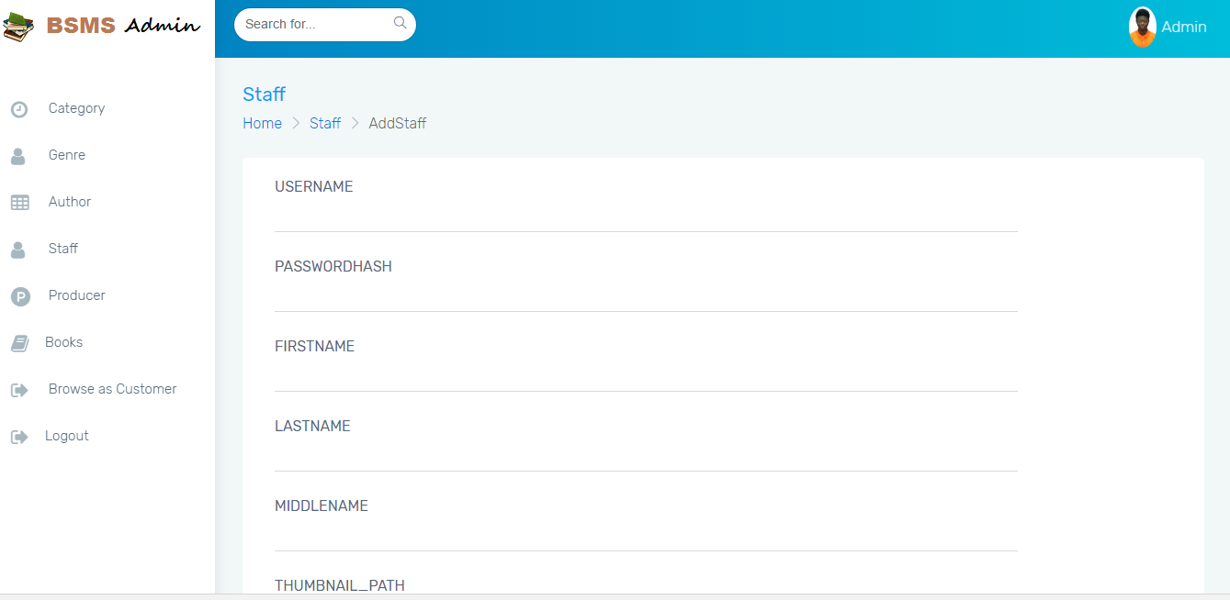

Use Case ID |  |  | AM03 |  | Version | 1.0
Use Name |  |  | Register Staff
Actor |  |  | Admin
Description |  |  | This functionality allow Admin to create a staff in the system, the functionality is only allow of the admin, as a staff is not allowed to register him or herself, after the below case is executed in a normal case staff will be allowed to login to the system
Precondition |  |  | - Admin must own a computer of any type  - Admin must be logged on to the system  - Admin should navigate to Add Staff by clicking in the navigation bar “Staff” -> “Add Staff”
Trigger
Post-Condition |  |  | Before clicking on the register button Admin must make sure that (*) field are not null and are valid.
Main flows
Step | Actor |  | Action
1 | Admin |  | Type URL into location field of internet browser and then press enter and navigate to the Add Staff from the navigation bar
2 | BSMS |  | Display Registration screen with the following fields:  - User Name  - Email  - ……..  - …….  -Add Staff button
3 | Admin |  | - Fills in correct registration data in the (*) fields  - Click the Add Staff button
4 | BSMS |  | Validate registration information, if correct is correct entered in a normal case. Staff Addition success Information message is shown to Admin.
Alternative flows
AT1 |  | Alternative flow, should incase an error occur in the program, if any of the (*) fields is empty or contains incorrect input.
Step |  | Actor |  | Action
2.1 |  | BSMS |  | Display Registration page with message “(*) fields are required and must contain valid values”

Business Rules
# | Rule Description
RGBR05 | Email Field must be valid
RGBR06 | Email cannot be reused, “Email Already in use”

Logout

Use Case ID |  | AM04 | Version | 1.0
Use Name |  | Logout
Actor |  | Customer, Staff, Admin
Description |  | This functionality specifically allow all type of logged users to sign out of the system, On click of logout icon or text from any page E-U will be redirected to Login page
Precondition |  | - Customer, Staff or Admin should have been previously logged in to the system
Trigger |  | Logout button clicked from the navigation bar from any page
Post-Condition |  | On Logging out BSMS will redirect users to the home page and allow them to browse like a normal guest.
Main flows
Step | Actor | Action
1 | Customer  Admin  Staff | Click on the Logout hyperlink in the any page
2 | BSMS | Redirect to Home Page

Forget Password

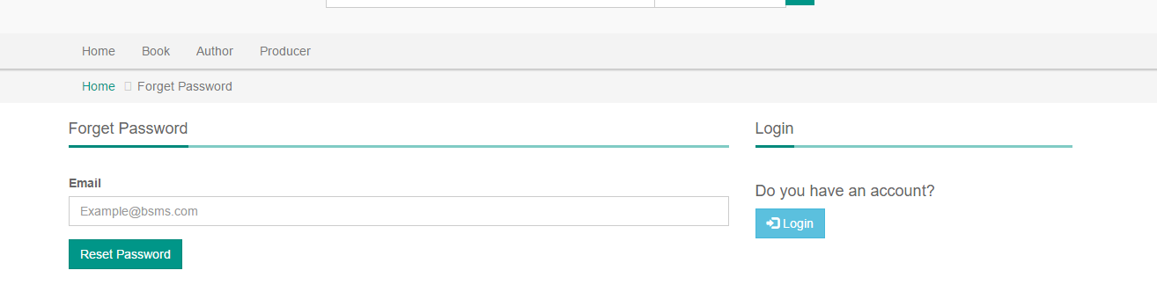

Use Case ID |  |  | AM05 |  | Version | 1.0
Use Name |  |  | Forget Password
Actor |  |  | Staff, Customer
Description |  |  | The forget password is used to retriever users passwords should incase they lose their previous password, a lot of user have varities of password they use in registering account, BSMS allow users who forget their password the functionality to reset their passwords
Precondition |  |  | - To use this feature user must have a valid BSMS account,  - Staff or customers must remember and have full access to their own email.  - Staff or Customer clicked on the forget password on the login page  - E-U filled in correct existing email in the system
Trigger |  |  | Forget Password hyperlink clicked from the login page
Post-Condition |  |  | N/A
Main flows
Step | Actor |  | Action
1 | Customer  Staff |  | Type URL into location field of internet browser and then press enter and navigate to the Login page in the navigation bar, click on forget password.
2 | BSMS |  | Display Forget Password page with the following field:  - Email  -Add Staff button
3 | Customer  Staff |  | - Fills in correct registration data in the (*) fields  - Click the Add Staff button
4 | BSMS |  | Validate email, if email is in correct format and exist in our system email notification will send in-order to move on to the next process
Alternative flows
AT1 |  | Alternative flow, should incase an error occur in the program, if Email fields is empty or contains incorrect input.
Step |  | Actor |  | Action
2.1 |  | BSMS |  | Display Registration page with message “(*) fields are required and must contain valid values”

Business Rules
# | Rule Description
FGBR01 | Email Address must be valid
FGBR02 | Email Address must have previously exist in BSMS

Category Management

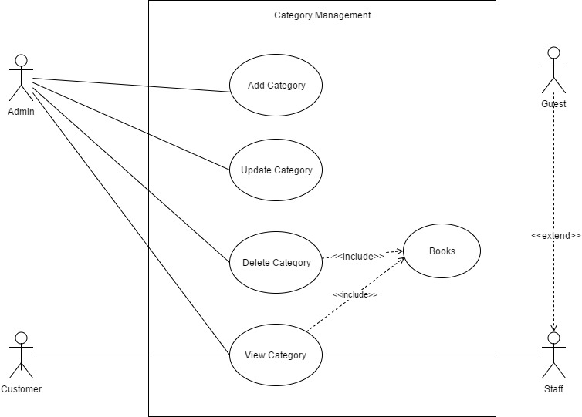 Figure 2.3.2

Add Category

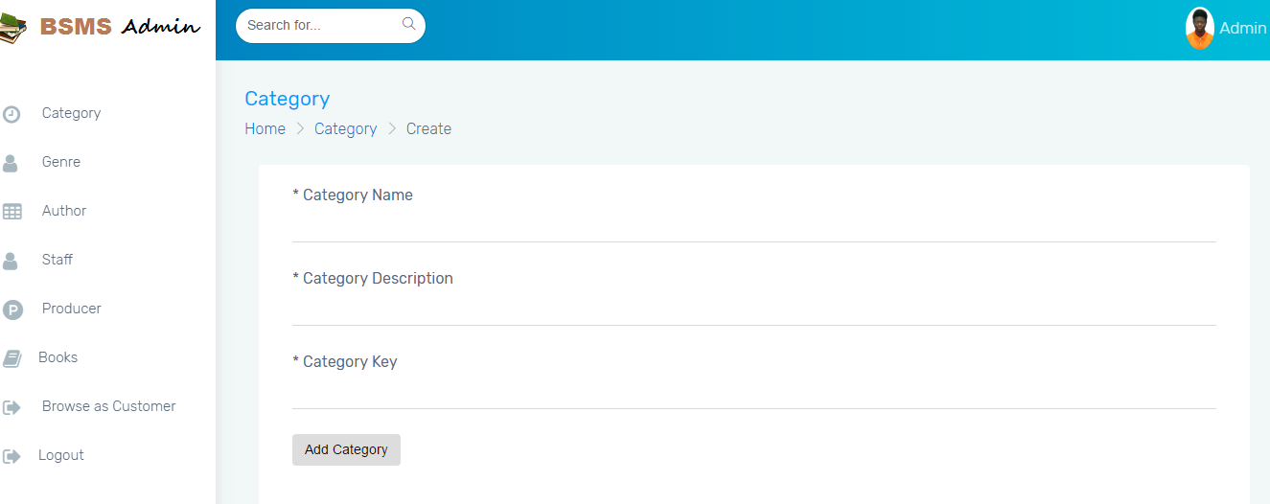

Use Case ID |  |  | CM01 |  | Version | 1.0
Use Name |  |  | Add Category
Actor |  |  | Admin
Description |  |  | In order to have category in our system, the admin might need to add one or more category so that we can categorize our books.  Adding Category in to the system is only allowed of the admin, which after the staff might add new book under the category.
Precondition |  |  | An admin needs to be logged in to the system with valid account information
Trigger |  |  | Add Category button click
Post-Condition |  |  | Category List Page
Main flows
Step | Actor |  | Action
1 | Admin |  | Hovers on the category from the navigation bar and then clicked on the add category button.
2 | BSMS |  | Display Add Category page with the following field:  - Name  -Description  -Upload Thumbnail  -Add Category Button
3 | Admin |  | - Fills in correct registration data in the (*) fields  - Click the Add Category button
4 | BSMS |  | Validate category information, if category fields are correct in a normal case. Category addition success Information message is shown to Admin.
Alternative flows
AT1 |  | Alternative flow, should incase an error occur in the program, if any of the (*) fields is empty or contains incorrect input.
Step |  | Actor |  | Action
2.1 |  | BSMS |  | Display Add category page with message “(*) fields are required and must contain valid values”

Business Rules
# | Rule Description
ACBR01 | Category name must not be null and length must be greater than or equals 3
ACBR02 | Category Image is not optional.

Delete Category

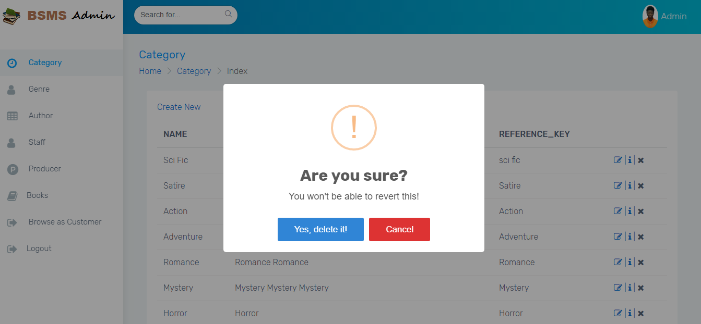

Use Case ID |  |  | CM02 |  | Version | 1.0
Use Name |  |  | Delete Category
Actor |  |  | Admin
Description |  |  | This functionality allow previously created category to be deleted from the system when they are no more needed, deleting of categories is a functionality allowed of the Admin user alone.
Precondition |  |  | An admin needs to be logged in to the system with valid account information
Trigger |  |  | Click the delete button on any category
Post-Condition |  |  | N/A
Main flows
Step | Actor |  | Action
1 | Admin |  | Click on the Delete category button in the category List page
2 | BSMS |  | Show delete confirm message
3 | Admin |  | Admin click “Ok” in the confirm message box
4 | BSMS |  | Delete Category from the system.
Alternative flows
AT1 |  | The Admin click cancel on the confirm message box shown on the screen
Step |  | Actor |  | Action
2.1 |  | BSMS |  | Dispose the action

Update Category

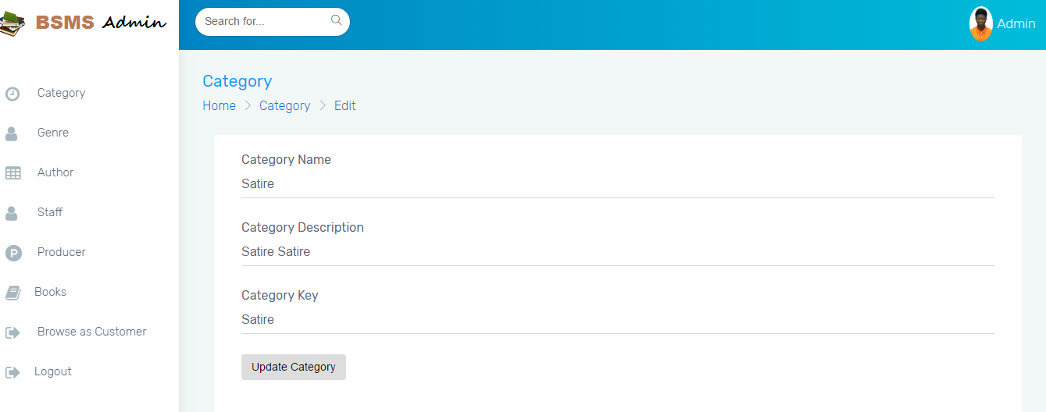

Use Case ID |  |  | CM03 |  | Version | 1.0
Use Name |  |  | Update Category
Actor |  |  | Admin
Description |  |  | This functionality allow previously created category to be edited if there exist any wrong information, editing information of category including the category name and other information e.g. changing category name from “Science Fiction” to “Sci Fi”
Precondition |  |  | An admin needs to be logged in to the system with valid account information
Trigger |  |  | Update Button
Post-Condition |  |  | Category List page
Main flows
Step | Actor |  | Action
1 | Admin |  | Click on edit button on top any category in the category list page.
2 | BSMS |  | Display update page with pre-populated data values that belongs to the category update button was clicked on.
3 | Admin |  | Admin change desired fields then click the update button
4 | BSMS |  | Display a confirm message to be sure, the Admin really want to update this category “Are you sure you want to update this category information”
5 | Admin |  | Click ok on the confirmation message
6 | BSMS |  | Update Category Information as update by the admin.
Alternative flows
AT1 |  | The Admin click cancel on the confirm message box shown on the screen
Step |  | Actor |  | Action
2.1 |  | BSMS |  | Dispose the action
AT2 |  | The Admin Click cancel before clicking on the Update button on the page
 |  | BSMS |  | Redirect back to Category list page

# | Rule Description
UCBR01 | Category name must not be null and length must be greater than or equals 3
UCBR02 | Category Image is not optional.

View Category
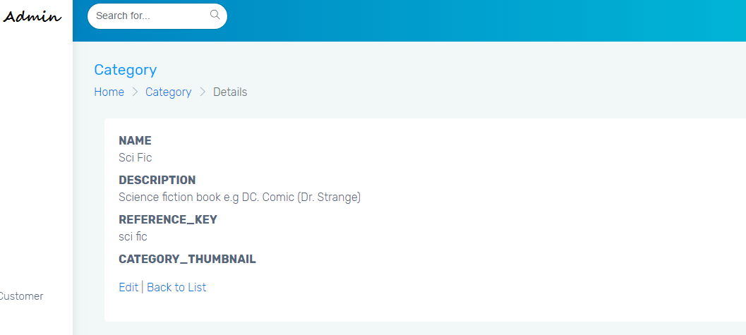
Use Case ID |  | CM04 | Version | 1.0
Use Name |  | View Category
Actor |  | Admin, Staff, Customers, Guest
Description |  | This allows users of any access level to view categories so that they can view books under this category.  .
Precondition |  | An admin needs to be logged in to the system with valid account information
Trigger |  | Click category button in the navigation bar from any page
Post-Condition |  | Category List page
Main flows
Step | Actor | Action
1 | Admin  Customer  Staff  Guest | Click on Category from the navigation bar
2 | BSMS | Display list of categories with buttons under each one of them “View glyph icon ” or “View”

View Books

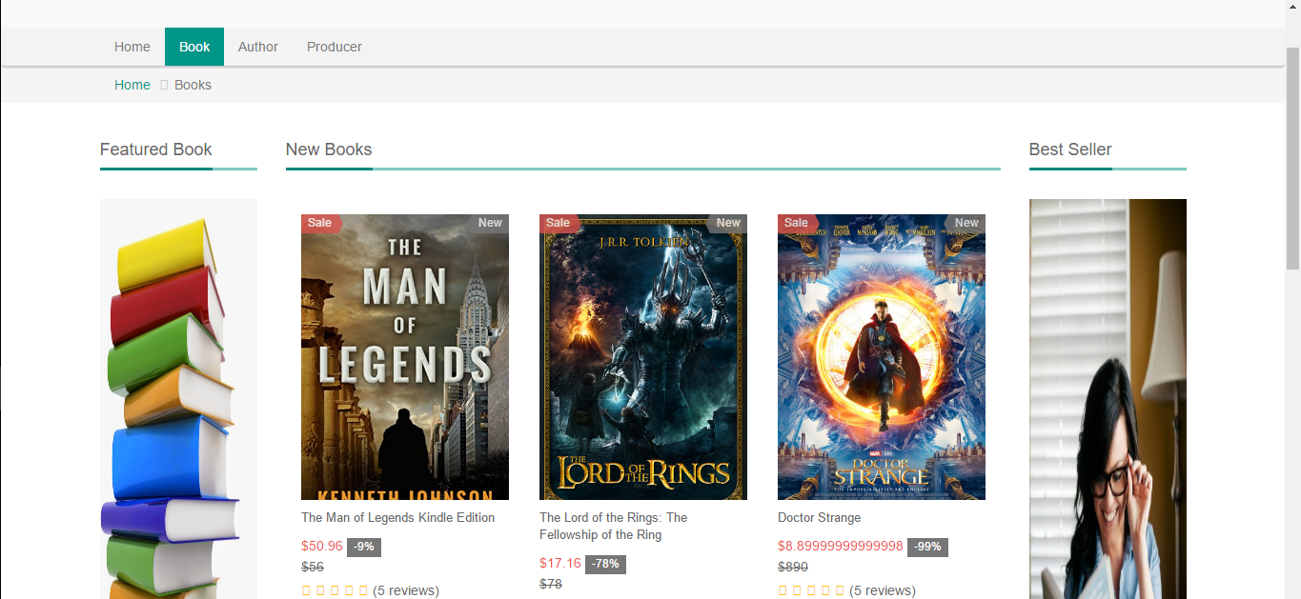

Use Case ID |  | CM05 | Version | 1.0
Use Name |  | View Books
Actor |  | Admin, Staff, Guest, Customer
Description |  | This functionality allow previously created category to be edited if there exist any wrong information.
Precondition |  | An admin needs to be logged in to the system with valid account information
Trigger |  | Click on Glyph icon view or “View” button
Post-Condition |  | Book List page
Main flows
Step | Actor | Action
1 | Admin, Staff, Guest, Customer | Click on Glyph icon view or “View” button
2 | BSMS | Display Book list page with all book within the selected category

Genre Management

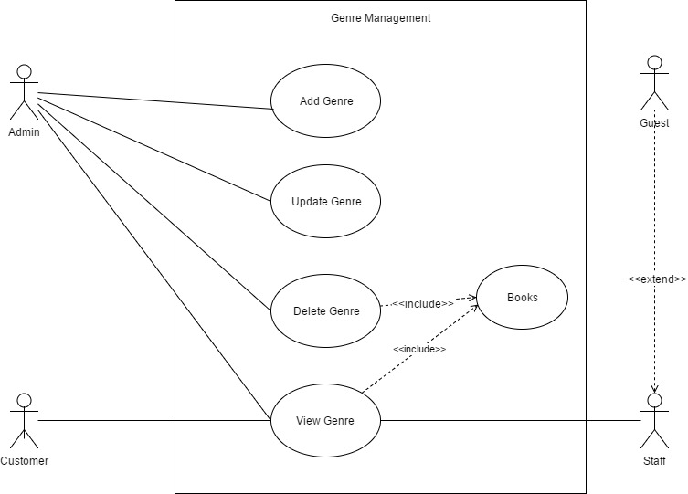
Figure 2.3.2

Add Genre

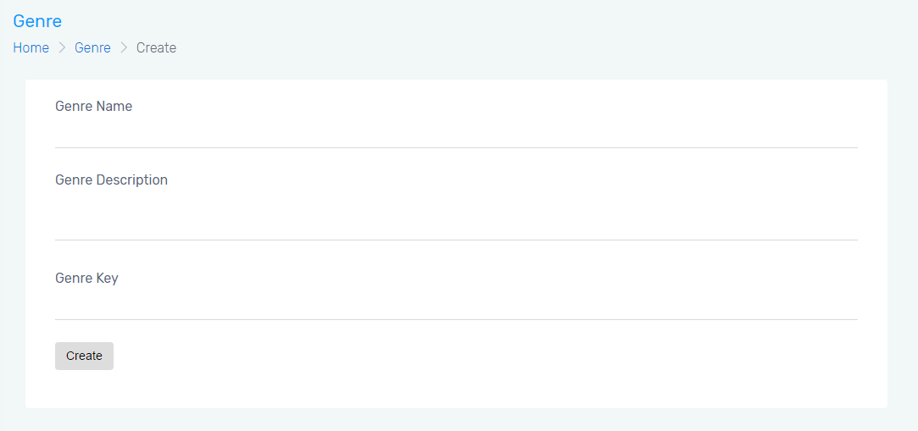

Use Case ID |  |  | GM01 |  | Version | 1.0
Use Name |  |  | Add Genre
Actor |  |  | Admin
Description |  |  | In order to have Genre in our system, the admin might need to add one or more genre so that each categorize can use the genre, inorder to add a book into BSMS, the admin need to add an equivalent genre that match that of the new book.
Precondition |  |  | An admin needs to be logged in to the system with valid account information
Trigger |  |  | Add Genre button click
Post-Condition |  |  | Genre List Page
Main flows
Step | Actor |  | Action
1 | Admin |  | Hovers on the genre from the navigation bar and then clicked on the add genre button.
2 | BSMS |  | Display Add Genre page with the following field:  - Name  -Description  -Upload Thumbnail  -Add Genre Button
3 | Admin |  | - Fills in correct registration data in the (*) fields  - Click the Add Genre button
4 | BSMS |  | Validate genre information, if genre fields are correct in a normal case. Genre addition success Information message is shown to Admin.
Alternative flows
AT1 |  | Alternative flow, should incase an error occur in the program, if any of the (*) fields is empty or contains incorrect input.
Step |  | Actor |  | Action
2.1 |  | BSMS |  | Display Add Genre page with message “(*) fields are required and must contain valid values”

Business Rules
# | Rule Description
AGBR01 | Genre name must not be null and length must be greater than or equals 3
AGBR02 | Genre Image is not optional.

Delete Genre

Use Case ID |  |  | GM02 |  | Version | 1.0
Use Name |  |  | Delete Genre
Actor |  |  | Admin
Description |  |  | This functionality allow previously created genre to be deleted from the system when they are no more needed, assuming the case in which the admin add duplicate book genre and wish to delete the irrelevant one, then this functionality will play a key role in completing this action.
Precondition |  |  | An admin needs to be logged in to the system with valid account information
Trigger |  |  | Click the delete button on any genre
Post-Condition |  |  | N/A
Main flows
Step | Actor |  | Action
1 | Admin |  | Click on the Delete genre button in the genre List page
2 | BSMS |  | Show delete confirm message
3 | Admin |  | Admin click “Ok” in the confirm message box
4 | BSMS |  | Delete genre from the system.
Alternative flows
AT1 |  | The Admin click cancel on the confirm message box shown on the screen
Step |  | Actor |  | Action
2.1 |  | BSMS |  | Dispose the action

Update Genre

Use Case ID |  |  | GM03 |  | Version | 1.0
Use Name |  |  | Update Genre
Actor |  |  | Admin
Description |  |  | This functionality allow previously created genre to be edited if there exist any wrong information, editing information of genre including the genre name and other information e.g. changing genre name from “Above 18” to “18+”, this functionality will play a key role if the admin make mistake or wish to make a major change in the system.
Precondition |  |  | An admin needs to be logged in to the system with valid account information
Trigger |  |  | Update Button
Post-Condition |  |  | Category List page
Main flows
Step | Actor |  | Action
1 | Admin |  | Click on edit button on top any genre in the category list page.
2 | BSMS |  | Display update page with pre-populated data values that belongs to the genre update button was clicked on.
3 | Admin |  | Admin change desired fields then click the update button
4 | BSMS |  | Display a confirm message to be sure, the Admin really want to update this genre “Are you sure you want to update this genre information”
5 | Admin |  | Click ok on the confirmation message
6 | BSMS |  | Update genre Information as updated by the admin.
Alternative flows
AT1 |  | The Admin click cancel on the confirm message box shown on the screen
Step |  | Actor |  | Action
2.1 |  | BSMS |  | Dispose the action
AT2 |  | The Admin Click cancel before clicking on the Update button on the page
 |  | BSMS |  | Redirect back to genre list page

# | Rule Description
UGBR01 | Genre name must not be null and length must be greater than or equals 3
UGBR02 | Genre Image is not optional.

View Genre

Use Case ID |  | GM04 | Version | 1.0
Use Name |  | View Genre
Actor |  | Admin, Staff, Customers, Guest
Description |  | This allows users of any access level to view genre so that they can view books under this genre, Viewing genre means viewing all information that are embedded in
Precondition |  | An admin needs to be logged in to the system with valid account information
Trigger |  | Click genre button in the navigation bar from any page
Post-Condition |  | Genre List page
Main flows
Step | Actor | Action
1 | Admin  Customer  Staff  Guest | Click on Genre from the navigation bar
2 | BSMS | Display list of genre with buttons under each one of them “View glyph icon ” or “View”

View Books

Use Case ID |  | GM05 | Version | 1.0
Use Name |  | View Books
Actor |  | Admin, Staff, Guest, Customer
Description |  | This functionality allow previously created genre to be edited if there exist any wrong information.
Precondition |  | E-U of any type navigates to the genre page, either when logged in or not.
Trigger |  | Click on Glyph icon view or “View” button
Post-Condition |  | Book List page
Main flows
Step | Actor | Action
1 | Admin | Click on Glyph icon view or “View” button
2 | BSMS | Display Book list page with all book within the selected genre

Staff Management
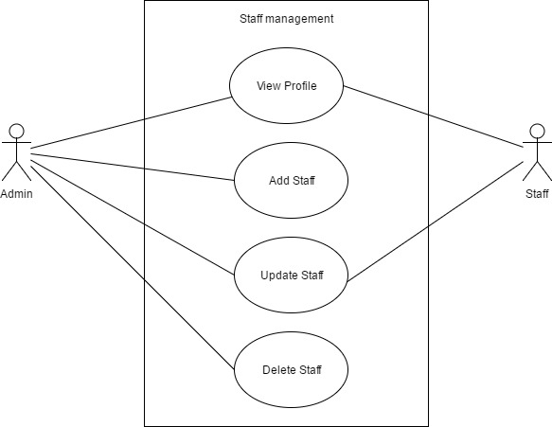
Figure 2.3.4

View Profile

Use Case ID |  | SM01 | Version | 1.0
Use Name |  | View Profile
Actor |  | Admin, Staff
Description |  | This functionality allow staff to view his own profile and also allow the admin to view profile or any staff, in-case if he need to find out some information about his staffs
Precondition |  | - Staff click on his thumbnail image or name on the navigation bar,  - Admin can view list of staffs in the system and click on the button View Profile
Trigger |  | View Profile hyperlink, image icon in the navigation bar clicked or name
Post-Condition |  | Profile Page
Main flows
Step | Actor | Action
1 | Staff | Click on his/her image thumbnail or name in the navigation bar from any page
2 | BSMS | Redirect staff to his/her own profile page
3 | Admin | - Go to list of staff on his/her dashboard  - click view profile button on any staff his wish to see
 | BSMS | Display staff profile page to admin

Add Staff

For this functional requirement, kindly refer to AM03 in the Authentication Management.

Update Staff

Use Case ID |  |  | SM02 |  | Version | 1.0
Use Name |  |  | Update Staff
Actor |  |  | Admin
Description |  |  | This functionality allow previously created Staff to be edited if there exist any wrong information.
Precondition |  |  | An admin needs to be logged in to the system with valid account information
Trigger |  |  | Update Button
Post-Condition |  |  | Category List page
Main flows
Step | Actor |  | Action
1 | Admin |  | Click on edit button on top any Staff in the category list page.
2 | BSMS |  | Display update page with pre-populated data values that belongs to the Staff update button was clicked on.
3 | Admin |  | Admin change desired fields then click the update button
4 | BSMS |  | Display a confirm message to be sure, the Admin really want to update this Staff “Are you sure you want to update this Staff information”
5 | Admin |  | Click ok on the confirmation message
6 | BSMS |  | Update Staff Information as updated by the admin.
Alternative flows
AT1 |  | The Admin click cancel on the confirm message box shown on the screen
Step |  | Actor |  | Action
2.1 |  | BSMS |  | Dispose the action
AT2 |  | The Admin Click cancel before clicking on the Update button on the page
 |  | BSMS |  | Redirect back to Staff list page

# | Rule Description
UGBR01 | Staff name must not be null and length must be greater than or equals 3
UGBR02 | Staff Image is not optional.

Delete Staff

Use Case ID |  |  | SM03 |  | Version | 1.0
Use Name |  |  | Delete Staff
Actor |  |  | Admin
Description |  |  | This functionality allow previously created Staff to be deleted from the system when they are no more needed.
Precondition |  |  | An admin needs to be logged in to the system with valid account information
Trigger |  |  | Click the delete button on any Staff
Post-Condition |  |  | N/A
Main flows
Step | Actor |  | Action
1 | Admin |  | Click on the Delete Staff button in the Staff List page
2 | BSMS |  | Show delete confirm message
3 | Admin |  | Admin click “Ok” in the confirm message box
4 | BSMS |  | Delete taff from the system.
Alternative flows
AT1 |  | The Admin click cancel on the confirm message box shown on the screen
Step |  | Actor |  | Action
2.1 |  | BSMS |  | Dispose the action

Book Management

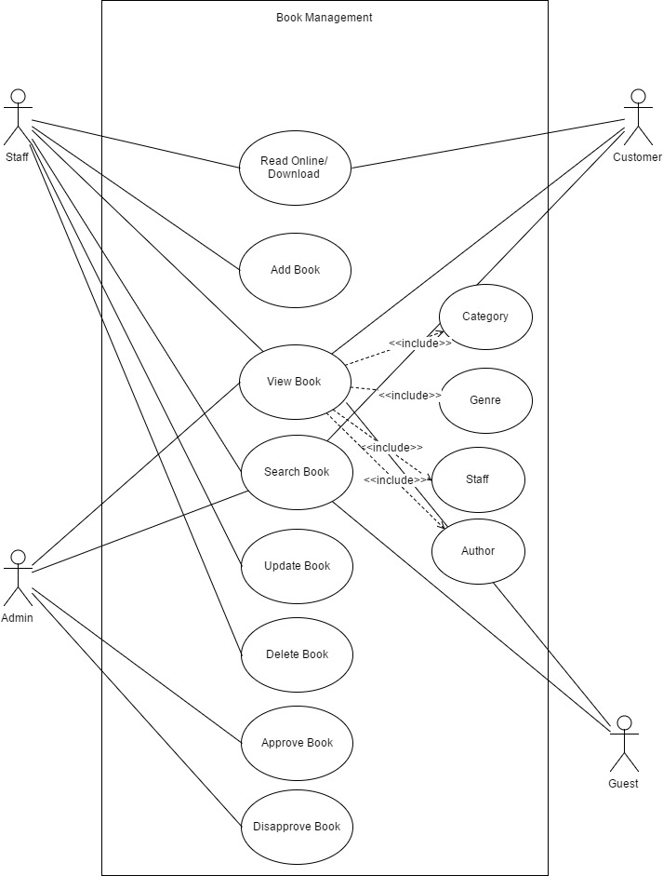
Figure 2.3.5

Read Book Online/Download

Use Case ID |  | BM01 | Version | 1.0
Use Name |  | Read Book Online/Download
Actor |  | Staff, Customer
Description |  | This feature main target is for customer to be able to View free books online or download
Precondition |  | - Staff or Customer is logged in to the system  - Selected book is tagged free
Trigger |  | Click on “View Glyph Icon” displayed on books tagged “Free” or download Glyph Icon
Post-Condition |  | pdf or document format of book is displayed on a new browser page
Main flows
Step | Actor | Action
1. | Staff  Customer | Customer click on “Download/Read Online Glyph Icon” on any book tagged free.  Staff click on preview book , on any book in the Book List page
2 | BSMS | - Send file to browser for download if softcopy format is in .docx file002E  - Preview File online if book softcopy is in pdf format

Add Book

Use Case ID |  |  | BM02 |  | Version | 1.0
Use Name |  |  | Add Book
Actor |  |  | Admin
Description |  |  | This functionality allow Admin to create a book in the system
Precondition |  |  | - Admin must own a computer of any type  - Admin must be logged on to the system  - Admin should navigate to Add Book by clicking in the navigation bar “Book” -> “Add Book”
Trigger
Post-Condition |  |  | Before clicking on the register button Admin must make sure that (*) field are not null and are valid.
Main flows
Step | Actor |  | Action
1 | Admin |  | Type URL into location field of internet browser and then press enter and navigate to the Book navigation bar then click on Add Book from the dropdown list
2 | BSMS |  | Display Registration screen with the following fields:  - Category  - Genre  - Name  - Author  - Producer  - …….  - Add Book button
3 | Admin |  | - Fills in correct registration data in the (*) fields  - Click the Add Book button
4 | BSMS |  | Validate registration information, if correct book information is entered in a normal case. Book Addition success Information message is shown to Admin.
Alternative flows
AT1 |  | Alternative flow, should incase an error occur in the program, if any of the (*) fields is empty or contains incorrect input.
Step |  | Actor |  | Action
2.1 |  | BSMS |  | Display Registration page with message “(*) fields are required and must contain valid values”

Business Rules
# | Rule Description
ABR01 | (*) field must cannot be empty
ABR02 | Book name should be greater than or equals length of 4
ABR03 | Book Name cannot be null
ABR04 | Price must be in decimal
ABR06 | Synopsis length must be more than 100 words

View Book

Use Case ID |  | BM03 | Version | 1.0
Use Name |  | View Book
Actor |  | Admin, Staff, Guest, Customer
Description |  | This functionality allow all users of any type to view a book, Viewing a book means you will see all the book details like Synopsis, Producer, ISBN number including book author and many other information
Precondition |  | On home page or Book list page, click the Detail button on any book of your own choice to view its information, to do this logging in is not required as guest users are also allow to access this functionality.
Trigger |  | “View Detail” button clicked on any book in either the home page or book list page
Post-Condition |  | N/A
Main flows
Step | Actor | Action
1 | Admin  Staff  Customer  Guest | - Navigate the list book page or the home page  - Find any book they want to view.  - Then click the “View Detail” at the lower side of the book
2 | BSMS | Redirect user to the Book Detail page

Search Book

For this functional requirement, kindly refer to use case SR01 in the Search Management.

Update Book

Use Case ID |  |  | BM04 |  | Version | 1.0
Use Name |  |  | Update Book
Actor |  |  | Staff
Description |  |  | This functionality allows previously created Book to be edited if there exist any wrong information.
Precondition |  |  | A Staff needs to be logged in to the system with valid account information
Trigger |  |  | Update Button
Post-Condition |  |  | Book List Page
Main flows
Step | Actor |  | Action
1 | Staff |  | Click on edit button on top any Book in the book list page.
2 | BSMS |  | Display update page with pre-populated data values that belongs to the Book update button was clicked on.
3 | Staff |  | Staff change desired fields then click the update button
4 | BSMS |  | Display a confirm message to be sure, the Staff really want to update this Book “Are you sure you want to update this Book information”
5 | Staff |  | Click ok on the confirmation message
6 | BSMS |  | Update Book Information as updated by the staff.
Alternative flows
AT1 |  | The Staff click cancel on the confirm message box shown on the screen
Step |  | Actor |  | Action
2.1 |  | BSMS |  | Dispose the action
AT2 |  | The Staff Click cancel before clicking on the Update button on the page
 |  | BSMS |  | Redirect back to Book list page

Business Rules
# | Rule Description
ABR01 | (*) field must cannot be empty
ABR02 | Book name should be greater than or equals length of 4
ABR03 | Book Name cannot be null
ABR04 | Price must be in decimal
ABR06 | Synopsis length must be more than 100 words

Delete Book

Use Case ID |  |  | BM05 |  | Version | 1.0
Use Name |  |  | Delete Book
Actor |  |  | Staff
Description |  |  | This functionality allow previously created Book to be deleted from the system when they are no more needed.
Precondition |  |  | An Staff needs to be logged in to the system with valid account information
Trigger |  |  | Click the delete button on any Book
Post-Condition |  |  | Book list page
Main flows
Step | Actor |  | Action
1 | Staff |  | Click on the Delete Book button in the Book List page
2 | BSMS |  | Show delete confirm message
3 | Staff |  | Staff click “Ok” in the confirm message box
4 | BSMS |  | Delete Book from the system.
Alternative flows
AT1 |  | The Staff click cancel on the confirm message box shown on the screen
Step |  | Actor |  | Action
2.1 |  | BSMS |  | Dispose the action

Approve Book

Use Case ID |  | BM06 | Version | 1.0
Use Name |  | Approve Book
Actor |  | Admin
Description |  | After staff add a book in the system they remain hidden to all users apart from admin, admin can remit that by reviewing and approving the book, this way the book will be published and all user will be able to see the book as part of the list
Precondition |  | Click on View Detail of book from “Pending approval page”
Trigger |  | Approve button clicked
Post-Condition |  | Pending Approval Book page
Main flows
Step | Actor | Action
1. | Admin | Admin go to the “Book” in the navigation bar and click on pending approval in the dropdown list.  Then Click the button View Detail
2. | BSMS | Displays Book Detail
3. | Admin | Review new book information and clicked approve
4. | BSMS | Publish book to all user.

Disapprove Book

Use Case ID |  | BM07 | Version | 1.0
Use Name |  | Disapprove Book
Actor |  | Admin
Description |  | When staff input invalid book information into the system, they remain hidden from all users apart from the admin, the admin can then take actions like disapproving/rejecting such book so that it will never have to appear to other E-U apart from him.  Rejected book are more like deleted book, the difference between both methods is that deleted book leave the system completely as they can never return but rejected books still serve the opportunity of being approve later in the future.
Precondition |  | Click on View Detail of book from “Pending approval page”
Trigger |  | Disapprove button clicked
Post-Condition |  | Pending Approval Book page
Main flows
Step | Actor | Action
1. | Admin | Admin go to the “Book” in the navigation bar and click on pending approval in the dropdown list.  Then Click the button View Detail
2. | BSMS | Displays Book Detail
3. | Admin | Review new book information and clicked disapprove or reject button
4. | BSMS | Keeps book hidden forever unless Admin take another action on such book.

Watch List Management

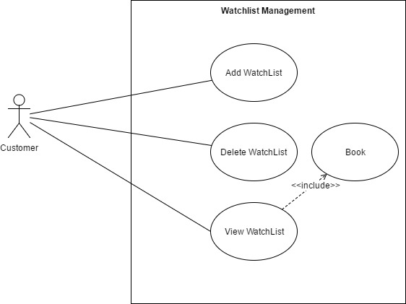
Figure 2.3.6

Add Wish List

Use Case ID |  | WM01 | Version | 1.0
Use Name |  | Add Wish List
Actor |  | Customer
Description |  | This feature allow users to add book to wish list, this functionally is more of personalizing some book you wish to read in the future or maybe customer wish to buy, it more like the favorite feature.
Precondition |  | Customer have a valid login information and he/she is logged into the system
Trigger |  | Click on the “Love Glyph Icon” in product list page or home page
Post-Condition |  | N/A
Main flows
Step | Actor | Action
1. | Customer | Click on the Icon or button “Add to Wish List” show on any book
2. | BSMS | Add book to customer wish list.

View Wish List

Use Case ID |  | WM02 | Version | 1.0
Use Name |  | View Wish List
Actor |  | Customer
Description |  | This feature allow user to be able to view product in their wish list
Precondition |  | Customer have a valid login information and he/she is logged into the system
Trigger |  | N/A
Post-Condition |  | Wish list page
Main flows
Step | Actor | Action
1. | Customer | Click on the wish list button or icon in the navigation bar
2. | BSMS | Display wish list page, where Customer can find all their books

Delete Wish List

Use Case ID |  | WM03 | Version | 1.0
Use Name |  | Add Wish List
Actor |  | Customer
Description |  | This feature allow users to remove book from wish list items
Precondition |  | Customer have a valid login information and he/she is logged into the system  Customer have previously add at least 1 product to his/her wish list  Customer have access the wish list page on the navigation bar
Trigger |  | “Remove from Wish list“ button click
Post-Condition |  | N/A
Main flows
Step | Actor | Action
1. | Customer | Click on the “Remove from wish list” button at the bottom of any book in the wish list page
2. | BSMS | Remove book from customer wish list.

Author Management

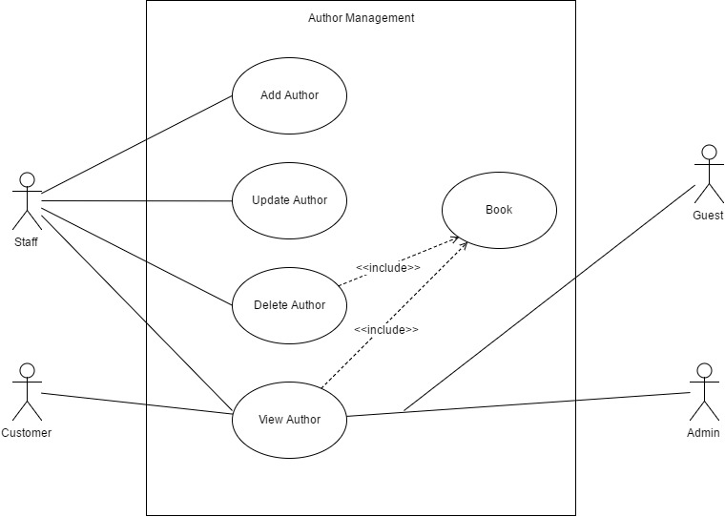
Figure 2.3.7

Add Author

Use Case ID |  |  | AUM01 |  | Version | 1.0
Use Name |  |  | Add Author
Actor |  |  | Staff
Description |  |  | In order to have Author in our system, the Staff might need to add one or more Author so that we can add author of our books.
Precondition |  |  | An Staff needs to be logged in to the system with valid account information
Trigger |  |  | Add Author button click
Post-Condition |  |  | Author List Page
Main flows
Step | Actor |  | Action
1 | Staff |  | Hovers on the Author from the navigation bar and then clicked on the add Author button in the dropdown list.
2 | BSMS |  | Display Add Author page with the following field:  - Name  -Description  -Upload Thumbnail  - …………..  - …………..  -Add Author Button
3 | Staff |  | - Fills in correct registration data in the (*) fields  - Click the Add Author button
4 | BSMS |  | Validate Author information, if Author fields are correct in a normal case. Author addition success Information message is shown to Staff.
Alternative flows
AT1 |  | Alternative flow, should incase an error occur in the program, if any of the (*) fields is empty or contains incorrect input.
Step |  | Actor |  | Action
2.1 |  | BSMS |  | Display Add Author page with message “(*) fields are required and must contain valid values”

Business Rules
# | Rule Description
ACBR01 | Author name must not be null and length must be greater than or equals 3
ACBR02 | Author Image is optional.

Delete Author

Use Case ID |  |  | AUM02 |  | Version | 1.0
Use Name |  |  | Delete Author
Actor |  |  | Staff
Description |  |  | This functionality allow previously created Author to be deleted from the system when they are no more needed.
Precondition |  |  | An Staff needs to be logged in to the system with valid account information
Trigger |  |  | Click the delete button on any Author
Post-Condition |  |  | N/A
Main flows
Step | Actor |  | Action
1 | Staff |  | Click on the Delete Author button in the Author List page
2 | BSMS |  | Show delete confirm message
3 | Staff |  | Staff click “Ok” in the confirm message box
4 | BSMS |  | Delete Author from the system.
Alternative flows
AT1 |  | The Staff click cancel on the confirm message box shown on the screen
Step |  | Actor |  | Action
2.1 |  | BSMS |  | Dispose the action

Update Author

Use Case ID |  |  | AUM03 |  | Version | 1.0
Use Name |  |  | Update Author
Actor |  |  | Staff
Description |  |  | This functionality allow previously created Author to be edited if there exist any wrong information.
Precondition |  |  | An Staff needs to be logged in to the system with valid account information
Trigger |  |  | Update Button
Post-Condition |  |  | Author List page
Main flows
Step | Actor |  | Action
1 | Staff |  | Click on edit button on top any Author in the Author list page.
2 | BSMS |  | Display update page with pre-populated data values that belongs to the Author update button was clicked on.
3 | Staff |  | Staff change desired fields then click the update button
4 | BSMS |  | Display a confirm message to be sure, the Staff really want to update this Author “Are you sure you want to update this Author information”
5 | Staff |  | Click ok on the confirmation message
6 | BSMS |  | Update Author Information as update by the Staff.
Alternative flows
AT1 |  | The Staff click cancel on the confirm message box shown on the screen
Step |  | Actor |  | Action
2.1 |  | BSMS |  | Dispose the action
AT2 |  | The Staff Click cancel before clicking on the Update button on the page
 |  | BSMS |  | Redirect back to Author list page

# | Rule Description
UCBR01 | Author name must not be null and length must be greater than or equals 3
UCBR02 | Author Image is not optional.

View Author

Use Case ID |  | AUM04 | Version | 1.0
Use Name |  | View Author
Actor |  | Staff, Admin, Customers, Guest
Description |  | This allows users of any access level to view categories so that they can view books under this Author.
Precondition |  | A Staff needs to be logged in to the system with valid account information
Trigger |  | Click Author button in the navigation bar from any page
Post-Condition |  | Author List page
Main flows
Step | Actor | Action
1 | Admin  Customer  Staff  Guest | Click on Author from the navigation bar
2 | BSMS | Display list of categories with buttons under each one of them “View glyph icon ” or “View”

View Books

Use Case ID |  | AUM05 | Version | 1.0
Use Name |  | View Books
Actor |  | Admin, Staff, Guest, Customer
Description |  | This functionality allow previously created Author to be edited if there exist any wrong information.
Precondition |  | An Staff needs to be logged in to the system with valid account information
Trigger |  | Click on Glyph icon view or “View” button
Post-Condition |  | Book List page
Main flows
Step | Actor | Action
1 | Admin, Staff, Guest, Customer | Click on Glyph icon view or “View” button
2 | BSMS | Display Book list page with all book within the selected Author

Profile Management

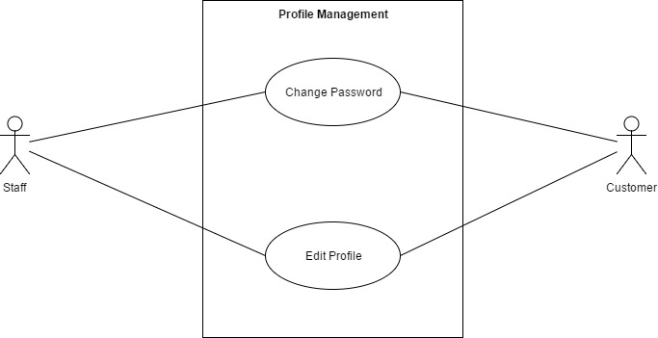
Figure 2.3.8

Change password

Use Case ID |  |  | PM01 |  | Version | 1.0
Use Name |  |  | Change password
Actor |  |  | Staff, Customer
Description |  |  | This system feature allows users to be able to change their own password.
Precondition |  |  | User must be logged into the system
Trigger |  |  | Settings button clicked from the navigation bar in the login page
Post-Condition |  |  | Login Page
Main flows
Step | Actor |  | Action
1. | Staff  Customer |  | Click on the setting hyperlink or icon from any page in the system
2. | BSMS |  | Display pop up with change password option
3. | Staff  Customer |  | Click on Change password option
4. | BSMS |  | Displays Change Password page with the following password fields:  - Previous Password  - New Password  - Confirm Password  - Change Password Button
5. | Staff  Customer |  | Input Correct information into the passwords fields
6. | BSMS |  | Change logged user password and redirect to login page to relogin with their new user detail.
Alternative flows
AT1
Step |  | Actor |  | Action
2.1 |  | Customer  Staff |  | Confirm password field does not match
2.2 |  | Customer  Staff |  | User current password is not correct

Business Rules
# | Rule Description
PMBR01 | Password fields must contain at-least a number
PMBR02 | Password text must be longer than 5 length

Edit Profile

Use Case ID |  |  | PM01 |  | Version | 1.0
Use Name |  |  | Edit Profile
Actor |  |  | Staff , Customer
Description |  |  | this feature allows users to be able to edit their own information
Precondition |  |  | User is logged in to the system with correct account information
Trigger |  |  | Edit Profile button Clicked
Post-Condition |  |  | Profile Detail Page
Main flows
Step | Actor |  | Action
1. | Staff  Customer |  | Click on the setting hyperlink or icon from any page in the system
2. | BSMS |  | Display a pop up with the following hyper link and Icons:  - Change Password  - View Profile  - Edit Profile
3. | Staff  Customer |  | Click on the Edit profile hyperlink or icon
4. | BSMS |  | Display Edit Profile page with pre-populated values
5. | Staff  Customer |  | Input all (*) Fields correctly and click on the Edit Profile Button
6. | BSMS |  | Update user information and show a popup message to inform user that profile have been updated.
Alternative flows
AT1 |  | (*) field are empty or are invalid
Step |  | Actor |  | Action
2.1 |  | BSMS |  | Display Edit profile page with error message saying “(*) fields are required and must be valid”

Business Rules
# | Rule Description
PMBR01 | First name, last name, middle name cannot be null and length must be greater than 2

System Search

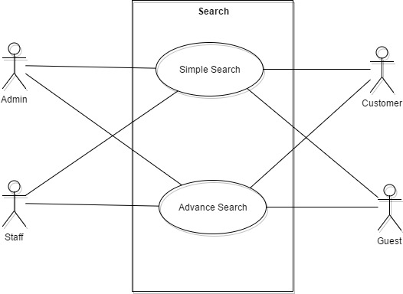 Figure 2.3.9

Simple Search

Use Case ID |  | SR01 | Version | 1.0
Use Name |  | Simple Search
Actor |  | Admin, Customer, Staff, Guest
Description |  | The allow user to search books through the search box on the navigation bar from any page
Precondition |  | Users of any type is browsing through our web application
Trigger |  | N/A
Post-Condition |  | Search Result Page
Main flows
Step | Actor | Action
1. | Admin  Customer  Staff  Guest | - Type a book name in the search functionality e.g. (“Lord of Ring”) user typed “Lord” or “Ring”.  - Select book category or leave it in all category  - click the search icon
2. | BSMS | Display search result page with book that match the given criteria

Advance Search

Use Case ID |  | SR02 | Version | 1.0
Use Name |  | Advance Search
Actor |  | Admin, Customer, Staff, Guest
Description |  | The allow user to search books or any other item using information’s like ISBN, Author and many other criteria
Precondition |  | Users of any type is browsing through our web application
Trigger |  | N/A
Post-Condition |  | Search Result Page
Main flows
Step | Actor | Action
1. | Admin  Customer  Staff  Guest | User clicked the advance search hyperlink in the navigation bar from any page
2. | BSMS | Displays advance search page with the following fields or more.  - Name  - Producer  - Author  - Category  - Genre  - Search type (“Author”, “Book”, “Category” …. etc)  - Search Button
3. | Admin  Customer  Staff  Guest | User input their search criteria correctly.
4. | BSMS | Display search result page

Producer Management

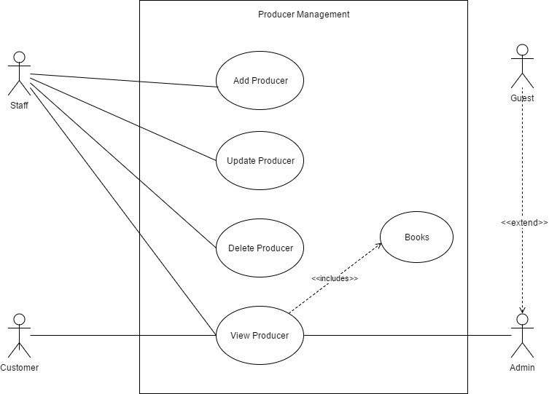
Figure 2.3.10

Add Producer

Use Case ID |  |  | PRM01 |  | Version | 1.0
Use Name |  |  | Add Producer
Actor |  |  | Staff
Description |  |  | In order to have Producer in our system, the admin might need to add one or more Producer so that each book can have more than or atleast one producer.
Precondition |  |  | An admin needs to be logged in to the system with valid account information
Trigger |  |  | Add Producer button click
Post-Condition |  |  | Producer List Page
Main flows
Step | Actor |  | Action
1 | Staff |  | Hovers on the Producer from the navigation bar and then clicked on the add Producer button.
2 | BSMS |  | Display Add Producer page with the following field:  - Name  -Description  -Upload Thumbnail  -Add Producer Button
3 | Staff |  | - Fills in correct registration data in the (*) fields  - Click the Add Producer button
4 | BSMS |  | Validate Producer information, if Producer fields are correct in a normal case. Producer addition success Information message is shown to Admin.
Alternative flows
AT1 |  | Alternative flow, should incase an error occur in the program, if any of the (*) fields is empty or contains incorrect input.
Step |  | Actor |  | Action
2.1 |  | BSMS |  | Display Add Producer page with message “(*) fields are required and must contain valid values”

Business Rules
# | Rule Description
PRCBR01 | Producer name must not be null and length must be greater than or equals 3
PRCBR02 | Producer Image is not optional.

Delete Producer

Use Case ID |  |  | PRM02 |  | Version | 1.0
Use Name |  |  | Delete Producer
Actor |  |  | Staff
Description |  |  | This functionality allow previously created Producer to be deleted from the system when they are no more needed.
Precondition |  |  | A Staff needs to be logged in to the system with valid account information
Trigger |  |  | Click the delete button on any Producer
Post-Condition |  |  | N/A
Main flows
Step | Actor |  | Action
1 | Staff |  | Click on the Delete Producer button in the Producer List page
2 | BSMS |  | Show delete confirm message
3 | Staff |  | Staff click “Ok” in the confirm message box
4 | BSMS |  | Delete Producer from the system.
Alternative flows
AT1 |  | The Staff click cancel on the confirm message box shown on the screen
Step |  | Actor |  | Action
2.1 |  | BSMS |  | Dispose the action

Update Producer

Use Case ID |  |  | PRM03 |  | Version | 1.0
Use Name |  |  | Update Producer
Actor |  |  | Staff
Description |  |  | This functionality allow previously created Producer to be edited if there exist any wrong information.
Precondition |  |  | A staff needs to be logged in to the system with valid account information
Trigger |  |  | Update Button
Post-Condition |  |  | Producer List page
Main flows
Step | Actor |  | Action
1 | Staff |  | Click on edit button on top any Producer in the Producer list page.
2 | BSMS |  | Display update page with pre-populated data values that belongs to the Producer update button was clicked on.
3 | Staff |  | Staff change desired fields then click the update button
4 | BSMS |  | Display a confirm message to be sure, the Staff really want to update this Producer “Are you sure you want to update this Producer information”
5 | Staff |  | Click ok on the confirmation message
6 | BSMS |  | Update Producer Information as update by the Staff.
Alternative flows
AT1 |  | The Staff click cancel on the confirm message box shown on the screen
Step |  | Actor |  | Action
2.1 |  | BSMS |  | Dispose the action
AT2 |  | The Staff Click cancel before clicking on the Update button on the page
 |  | BSMS |  | Redirect back to Producer list page

# | Rule Description
PUBR01 | Producer name must not be null and length must be greater than or equals 3
PUBR02 | Producer Image is not optional.

View Producer

Use Case ID |  | PRM04 | Version | 1.0
Use Name |  | View Producer
Actor |  | Admin, Staff, Customers, Guest
Description |  | This allows users of any access level to view categories so that they can view books under this Producer.
Precondition |  | An admin needs to be logged in to the system with valid account information
Trigger |  | Click Producer button in the navigation bar from any page
Post-Condition |  | Producer List page
Main flows
Step | Actor | Action
1 | Admin  Customer  Staff  Guest | Click on Producer from the navigation bar
2 | BSMS | Display list of categories with buttons under each one of them “View glyph icon ” or “View”

View Books

Use Case ID |  | PRM05 | Version | 1.0
Use Name |  | View Books
Actor |  | Admin, Staff, Guest, Customer
Description |  | This functionality allow previously created Producer to be edited if there exist any wrong information.
Precondition |  | An admin needs to be logged in to the system with valid account information
Trigger |  | Click on Glyph icon view or “View” button
Post-Condition |  | Book List page
Main flows
Step | Actor | Action
1 | Admin, Staff, Guest, Customer | Click on Glyph icon view or “View” button
2 | BSMS | Display Book list page with all book within the selected Producer

Non-functional Specification

Reliability
BSMS should always be available, incase if there is any causalities the Web app should come back online with short period of time.
Critical maintenance that requires the server to completely shut down should be done in the mid-night as only few users tend to use the system in the night.

Performance Requirements
Code optimization should be done frequently in-order for the system to run faster as more and more user come into the system.

Availability
Our web application should be available 24/7, which means the application only goes inactive when the server goes down for critical maintenance, which should be done only times in a year as scheduled.

Response time
Response time per request should not be more than 1 minute per request made unless there is an internal error in the web application, or the data users is looking for cannot be processed on our server

User Interface
It is required that the user interface of our web application to be highly interactive and friendly, so that even a dummy can use our application as a guest or customer.
This web application will also be design with the mobile approach in mind (The Mobile First User Interface approach.) should be applied in our system, in such a way that our system understands the type of device E-U is viewing from and automatically adapt to the size of E-U screen.

Usability
System should be easy to in such a way that there is no need for any external training before E-U will be able to use the system
Friendly and modernize UI, Embossed text for clear view of the system.
English language as a world universal language will be implemented

Security Requirements
BSMS Web Application should implement MD5 security features in order to protect the system from potential attacks.
BSMS application should not be venerable to SQL injection attack

Hardware/Software Requirements
To access our web application you will need the following tools:

Browser of your choice: Preferably
For PC Users:

- Google Chrome

For Mobile Users:

- Google Chrome

